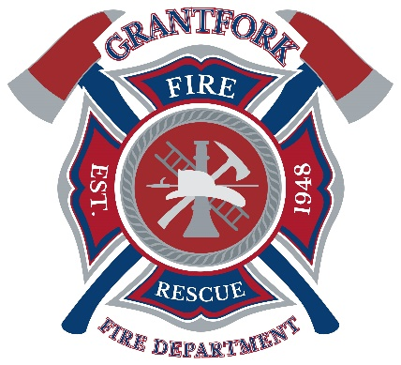
GRANTFORK FIRE PROTECTION DISTRICT
210 N. Locust Street, Highland, IL 62249
gvfd@agtelco.com

John Markus, Chief Scott Dressler, Assistant Chief
618-267-7241 618-779-3530

The Grantfork Fire Department is solely a volunteer fire department. It is comprised of 30 volunteers who perform all fire related and BLS related medical emergency services in our fire district. Our volunteers are not monetarily compensated.

Our volunteers complete bi-weekly training. We cover all aspects of fire & EMS training. Besides bi-weekly training, we host Bike Helmet training day and give away for every fourth grader every May. We hold fire prevention day at our local elementary school every October. We demonstrate how our extrication tools are used, vehicle air bag deployment demonstrations, fire extinguisher training utilizing the P.A.S.S. acronym and every other year we coordinate with our Air Evac team to land a helicopter and review how it operates.

We accrue most of our funds by holding our annual homecoming. With these funds we purchase new tools and equipment for our firefighters and also maintain our park for the community to use.

We volunteer our time and money to help the people in our community and keep them safe.

If any further information is needed, please contact Chief John Markus at 618-267-7241.

Sincerely,

Fire Chief
John Markus
Grantfork Fire Protection District

